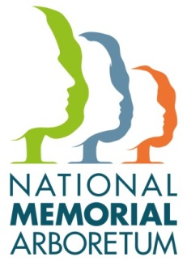

Group Presentation Booking Form

Privacy Statement
At the National Memorial Arboretum we take your privacy seriously and we will only use the information you have provided on this form to administer your presentation booking and correspond with you thereafter. We will use the contact details you have provided to telephone, email or write to you about your booking. We will also share your information, including your contact details with your allocated speaker, who will also contact you in advance of your presentation to discuss your requirements further. We promise to keep your personal information safe and secure.
We will hold your personal data for three years after your presentation. If you would like to update your contact details, please contact National Memorial Arboretum 01283 245100 or info@thenma.org.uk
For further information about how the National Memorial Arboretum processes your personal information and about your rights under data protection law, please see our privacy policy on our website www.thenma.org.uk.

Name of Group
Name of Contact
Address | Post Code
Telephone
Fax
E-mail
Date of Presentation
Venue
Venue Address | Post Code
Speaker Arrival Time
Time of Presentation
Speaker name – If you have a request for specific speaker*

*Please note we are unable to guarantee your requested speaker due to availability.
Our talks generally last for 45 minutes, with time for questions and answers. Charges are based on £25.00 plus 45p per mile round trip, which is calculated between the Arboretum and the Venue. You may, of course, contribute more if you wish. As a UK registered charity we welcome, and are grateful for, donations (Charity No. 1043992).

